Driver Installation Under Windows XP

- Step 1: Plug in the USB type A receptacle of the cable to the USB
connector of your computer.
Step 2: Place the enclosed CD Driver into the CD ROM.
Step 3: Click “next” at the Found New Hardware Wizard screen.
See Figure 1
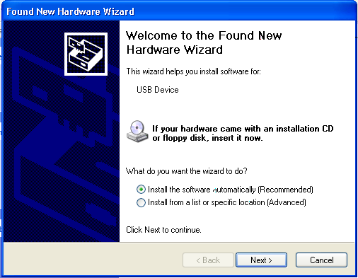
Figure 1

- Select the default location and click “next” to continue.
See Figure 2
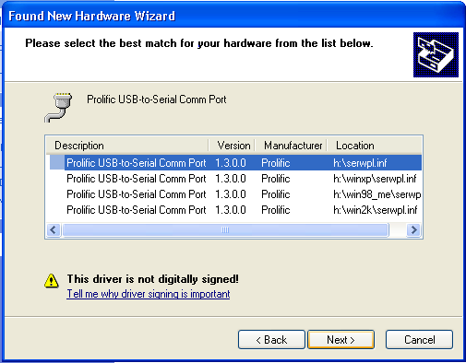
Figure 2

- Click “Continue Anyway” to proceed the installation.
See Figure 3

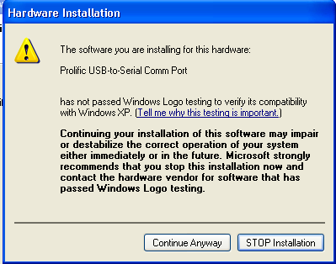
Figure 3

- The Wizard has finished installing the software, click
“Finish” to close the Wizard. See Figure 4.

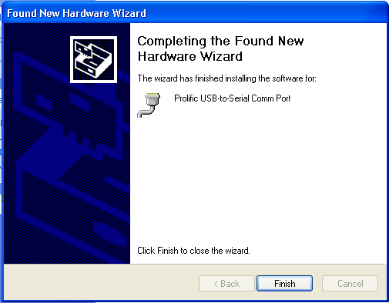
Figure 4

- Double click “My Computer” →”System Properties”→
”Device Manager” to make sure the device you install is
correctly displayed. See Figure 5

