Driver Installation Under Windows 98

- Step 1: Plug in the USB type A receptacle of the cable to the USB
connector of your computer.
Step 2: Place the enclosed CD Driver into the CD ROM.
Step 3: Click “next” to search for new drivers for USB Device.
. See Figure 1
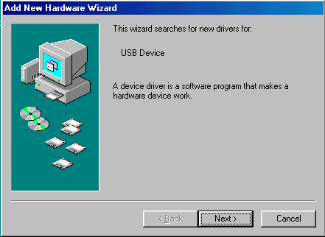
Figure 1

- Select ‘ Search for the best driver for your device’ and click “next”.
See Figure 2.
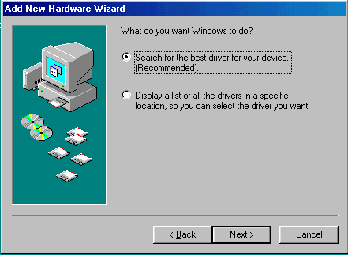
Figure 2

3. Specify the CD-ROM drive and click “next”. See Figure 3
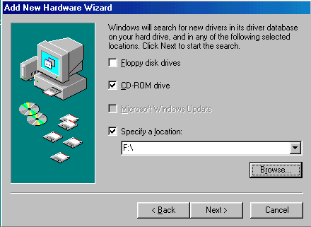
Figure 3

- Windows driver file will search for the device, click “next” to continue.
See Figure 4
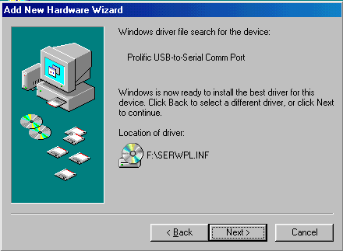
Figure 4

- Windows has finished installing the software, click “Finish” to close
the Wizard. See Figure 5

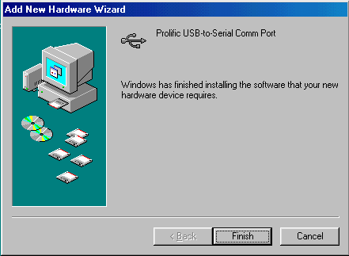
Figure 5

- Open “ Device Manager “ under System Properties and check if
There is the device you install under “ Universal Serial Bus controllers”.
See Figure 6
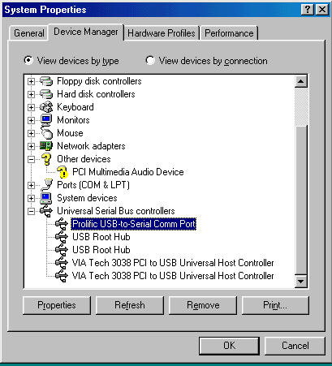
Figure 6

